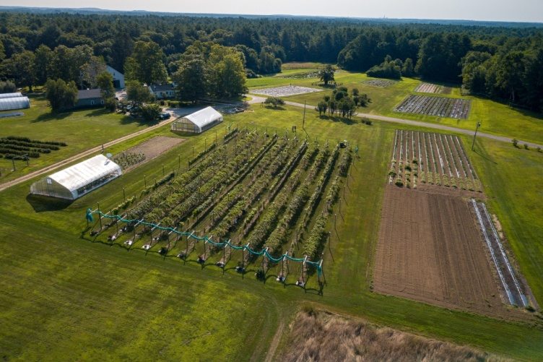
The purpose of the project is to understand the importance of doing a geological map and identify where the contact is located for the rocks.
ESCI 530 Field Geology Project 2:
Mapping a Geological Contact at UNH Horticulture Farm

Abstract:
The objective of this project is to learn how to do geological mapping and why it is important in the field. Through the map, we would be able to help locate mineral, energy, and water resources. Through this we can understand and locate natural hazards as well as to see how the environment impacts soil, drainage, agriculture, ecosystems. Our goal was to find the nature of contact between the Exeter Diorite and the Eliot formation. For this project we first created a base map of the UNH Horticulture farm located between the Durham main campus. We used various methods to be able to draw the base map with precision and spent a lot of time looking at the exposures in the field area to try and create a geologic map on the two types of rocks. The results were the outcrops that were mapped and observing their characteristics so that we could determine the type of rock it is.
Introduction:
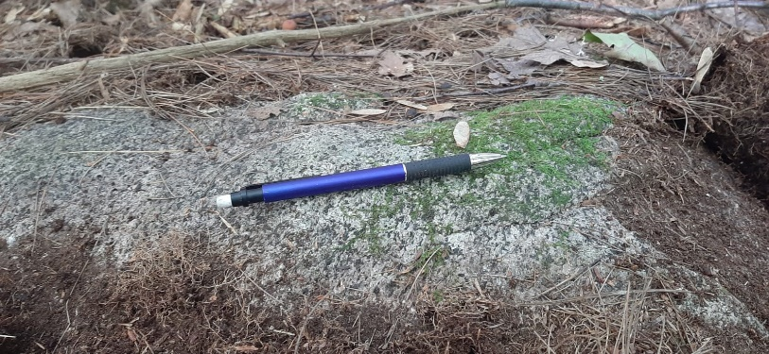
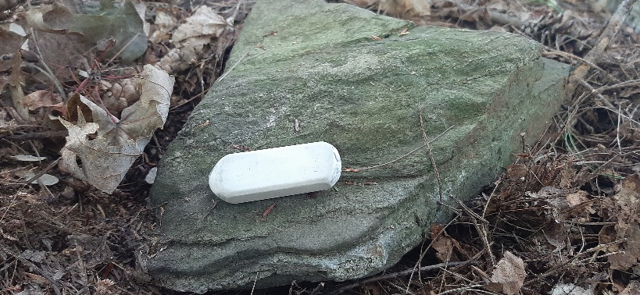
The question we researched about in this project was to identify nature of the contact between the Exeter Diorite and the Eliot Formation. The rock types were the most common in the area. Exeter Diorite has almost a medium- to coarse-grained which tell us that the crystals cooled fast enough to be that size. Because the magma cooled down slowly, deep within the crust, the resulting rock is intrusive. When you break down a small section of the rock, the minerals are mostly white but you can see few grey minerals. This tell us that the composition of the Exeter diorite is mostly plagioclase feldspar but there is still some biotite present. Whereas the Eliot formation streams from the Merrimack Group. It is a metamorphic rock that most likely consists of dark grey minerals such as calcareous quartzite. In the field site, they were not hard to identify since they have foliation. The area where we conducted our research was in a wood’s environment. There were both boulders as well as outcrops. It was mix because a lot of the rocks were muddled up together and it took some time to identify the outcrops. The two rocks types were mainly located in different areas. But there were very few places where it was evident that both the rocks are present. There was an outcrop where the rock was an Eliot formation but in in the middle of the rock there was a small surface area of Exeter diorite.
Eliot formation (Fig 2)
Exeter Diorite (Fig 1)
Methods:
This project used different methods to map a geological contact at UNH horticulture farm. The first method we did was a pace and compass method. For the compass that we used the magnetic declination was roughly 15 degrees west. I started mapping the place out from the end of the barn up until the end of the woods. Pacing was the first step in order to know the scale of the map, and once the scale was decided (which was 1cm = 15m), we were able to map the place by measuring and recording the bearings. Importance features such as the rock wall, fence, tree line and road were mapped though triangulation. At the same time GPS locations were taken at every stop I made for the map. I used the Garmin etrex 10 and the accuracy that I saw on the receiver was probably around 3-6 m while taking the measurements. This method was not just done for the nodes (points on the map that we took the bearing) but also for the outcrops. Global Positioning System (GPS) was also used to determine the longitude and the latitude of the nodes and the outcrops. The GPS was synched with at least four satellites to try and secure accuracy. The data was transferred into Google Earth for further analysis and evaluation. When it came to mapping the outcrops, triangulation was difficult to use due to lack of specific landmarks. But by pacing and measuring the bearings, I drew some of the outcrops but for most of them it was drawn from a rough estimation about their location. The error was calculated by comparing the contact that we drew to the USGS Map of New Hampshire.
Results:
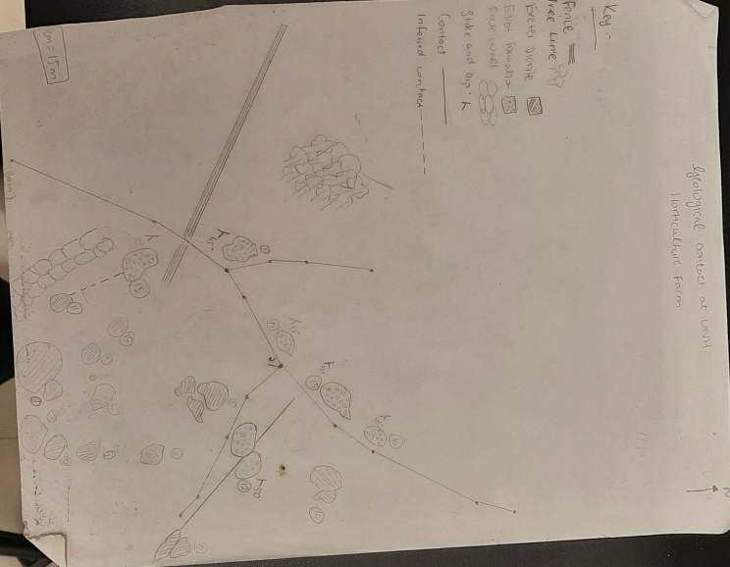
In order to identify the contact, we observed the two rock types. Some of the outcrops were Exeter Diorite and we spent a while observing in order to classify them as an Exeter Diorite. When we hammered a bit of the outcrop, the crystals could be characterized as large crystal sizes. It looked quite like the individual crystals were interlocked together but the rock itself was medium to course grained (Geosciences LibreTexts, 2021). There was a lot of cracks that could have been caused from weathering as well as dikes and veins which show that intrusions of the rock. Looking at this it can be stated that it is an intrusive igneous rock. The composition of this rock type could be pyroxene and quartz with bit of granite, all this comes from the color of the minerals within the rock since there were mostly white minerals than the grey ones. On the other hand, the Elliot formation, was identified on the opposite side of the farm. One of the clear indications was the foliation and the rock itself was coarse grained. The composition of the rock could be calcareous quartzite or quartz-mica schist, since the minerals grayish color. In order to construct accurate geologic map (Encyclopedia.com, 2021), we measured the strike and dip of Eliot formation rocks and the average strike and dip was 47.8.
Pace and Compass (Fig 3)
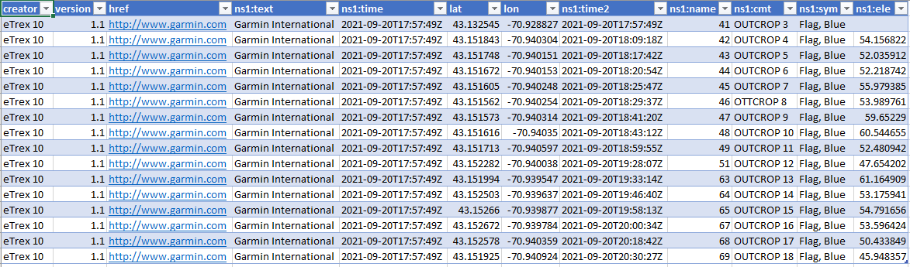
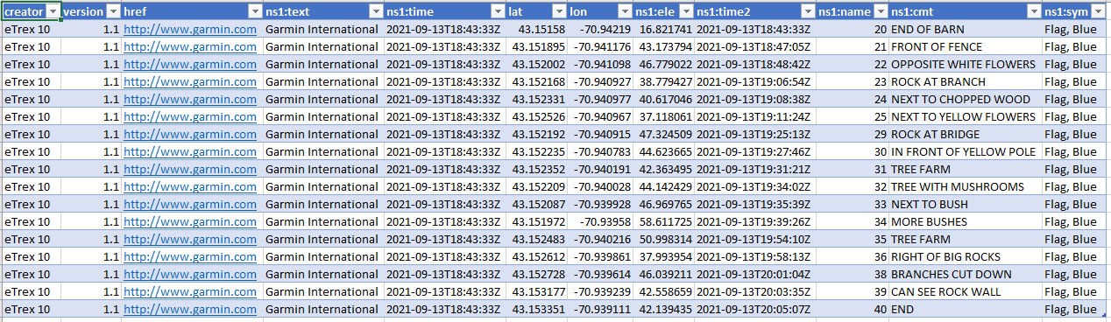
Outcrop waypoints (Table 2)
Nodes waypoints (Table 1)

Discussion:
The geological contact that we found was around the fork of the path. Both the type of rocks was found imbedded within each other. At first it was hard to see it but using the magnifying glass we were able to see the in the middle of an Elliot formation rock there was also the Exeter Diorite. It seemed to have been an intrusive contact (Geology In, 1970), the Exeter diorite was cutting across the Eliot formation. There was area near rock wall where we could infer that it was a geological contact, but it’s hard to determine it since not a lot of time was spent there. Some of the errors that could have come up and muddled with our findings would be the number of satellites in my GPS. In some locations I had six satellites while in others I would see only three. There were also a lot of boulders, so we needed to dig out around the rock to check if it was a rock fragment or an exposed rock.
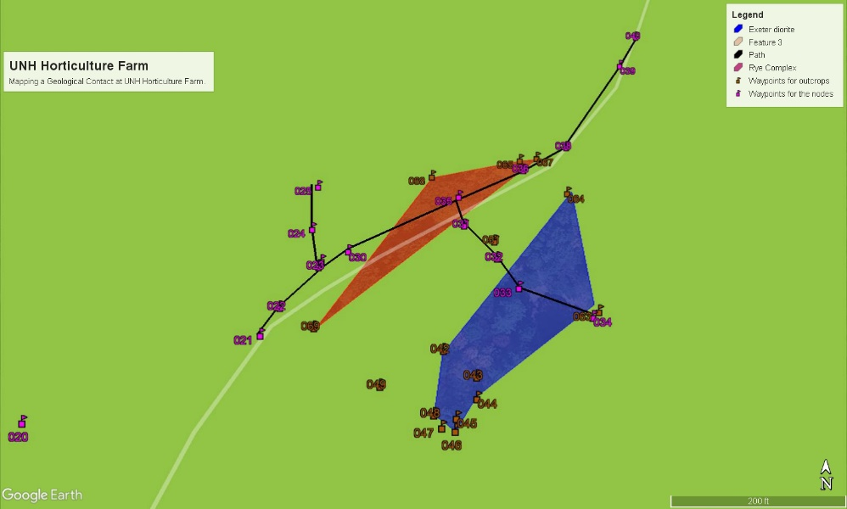
Overlaying the USGS map of the Bedrock Geology of New Hampshire, two of the most common rock types were Elliot formation and Exeter Diorite. The contact line was unclear but the field mostly consists of the Exeter Diorite. Zooming into the map, the field area was secured with the color green indicating it mostly consists of Exeter Diorite. But based on my observations, almost 75% of the outcrops that I located in the area was Exeter Diorite. But it was hard to do an error analysis since the USGS Map didn’t have the full data.
Google Earth Map (Fig 4)

Conclusions:
Our goals to find the nature of the contact between the Exeter Diorite and the Eliot Formation was met. It was located at the fork of the road next to Tree Hill. This was formed through an unconformity, intrusive contact. Looking at the orientation of this rock its strike and dip was 50°. It was hard to compare my field map with the USGS Map, since it didn’t have a detailed geologic bedrock of the field area we worked on. My methods of plotting the outcrops were not very accurate since many of them were mapped out through a rough estimation. Although this wouldn’t impact the goal of finding the contact, the outcrops in my pace and compass map wouldn’t match the GPS waypoints.
References
4.1: Classification of Igneous Rocks. July 26, 2021. Available: Geosciences LibreTexts <https://geo.libretexts.org/Bookshelves/Geology/Book%3A_An_Introduction_to_Geology_(Johnson_Affolter_Inkenbrandt_and_Mosher)/04%3A_Igneous_Processes_and_Volcanoes/4.01%3A_Classification_of_Igneous_Rocks> Accessed October 01, 2021
World of Earth Science. 22 Sep. 2021 Available: Encyclopedia.com. <https://www.encyclopedia.com/science/encyclopedias-almanacs-transcripts-and-maps/strike-and-dip >. Accessed October 01, 2021
Types of Unconformities. January 01, 1970 Available: Geology In <https://www.geologyin.com/2015/10/types-of-unconformities.html> Accessed October 01, 2021

